三芝區至林口區拖網漁業禁漁區經緯度座標圖表
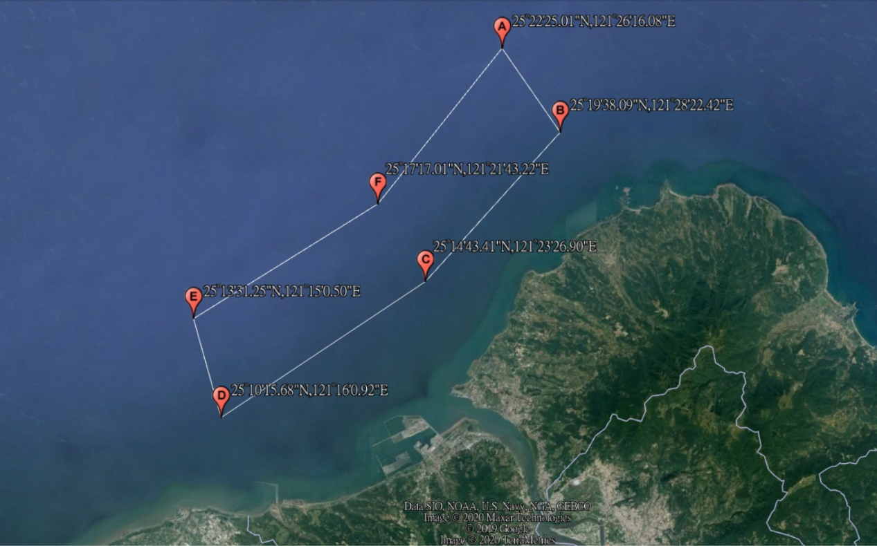
點位 | 經緯度(WGS-84座標系統)
A | 25°22'25.01"N,121°26'16.08"E
B | 25°19'38.09"N,121°28'22.42"E
C | 25°14'43.41"N,121°23'26.90"E
D | 25°10'15.68"N,121°16'0.92"E
E | 25°13'31.25"N,121°15'0.50"E
F | 25°17'17.01"N,121°21'43.22"E

