|  |  |  |  |  |  |  |  |  |  |  |  |  |  |  |  |  |  |  |  |  |  |  |  |  |  |  |  |  |  |  |  |  |
| --- | --- | --- | --- | --- | --- | --- | --- | --- | --- | --- | --- | --- | --- | --- | --- | --- | --- | --- | --- | --- | --- | --- | --- | --- | --- | --- | --- | --- | --- | --- | --- | --- |
| |  |  |  |  |  |  |  |  |  |  | | --- | --- | --- | --- | --- | --- | --- | --- | --- | --- | | **○○○○** **職工福利委員會委員暨職員〈會務人員〉名冊** | | | | | | | | | | | 職工福利委員會成立日期 | 屆別 | 選舉(改、補選)日期 | 福委會組織 | | 本屆委員任期起迄時間 | 會　　　　      址 | 電　　 話 | 職工  人數 | 連絡人姓名 | | 委員數 | 職員數 | |  |  |  |  |  |  |  |  |  |  | |
| |  |  |  |  |  |  | | --- | --- | --- | --- | --- | --- | | 職別 | 姓名 | 性別 | 任職部門及職稱 | 連任或新任 | 備註 | |  |  |  |  |  |  | |  |  |  |  |  |  | |  |  |  |  |  |  | |  |  |  |  |  |  | |  |  |  |  |  |  | |  |  |  |  |  |  | |  |  |  |  |  |  | |  |  |  |  |  |  | |  |  |  |  |  |  | |  |  |  |  |  |  | |  |  |  |  |  |  | |  |  |  |  |  |  | |  |  |  |  |  |  | |  |  |  |  |  |  | |  |  |  |  |  |  | |  |  |  |  |  |  | |  |  |  |  |  |  | |  |  |  |  |  |  | |  |  |  |  |  |  | |  |  |  |  |  |  | |
|  |
| 「職別」欄請依各委員實際狀況參考下列職別填寫 |

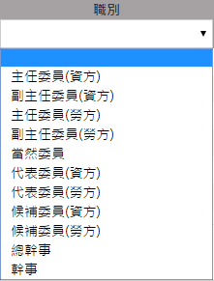

備註：職工福利委員會委員不得兼任總幹事、幹事